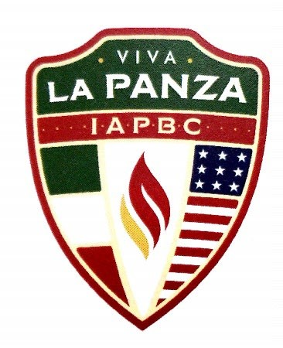
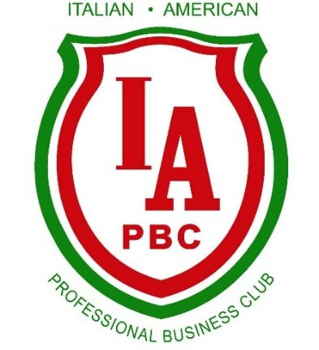
2026 IAPBC Annual Events

Jan 28th – Wine Down Wednesday- Membership Mixer (LaLa’s in the Lakes)
Feb 25th- Speaker Breakfast- 2026 Tax/Law Updates with Members Steven Dimengo & Angelina Milo (Buckingham’s, Doolittle & Burroughs, LLC- Embassy Pkwy)
March 25th- Wine Down Wednesday- Italian Genealogy with John Vallillo (Papa Joes)
April 22nd – Morra Tournament (Todaro’s)
May 14th - Scholarship Luncheon (Todaro’s)
June- Wine Down Wednesday- Wine Tasting (Nauti Vine)
July 9th- 11th - Italian American Festival (Downtown Akron)
July 17th- 19th - Festa Italiano (Cuyahoga Falls)
July 18th- Feast of Santo Stefano (Carovillese Club)
July 27th - Golf Outing (Silver Lake CC)
August 5th – Wine Down Wednesday- Bocce Dinner (The Teodosio’s home)
October 12th - Columbus Day (Café Arnone)
October 28th - Viva La Panza – (Todaro’s)
December- WinterBlast (Downtown Akron- Lock 3)
December 4th - Christmas GALA / Inaugural Dinner (Greystone Hall)

